CNC Hot Knife Heat Cutter Foam Cutter Fabric Cutter
CNC-8-0
Application:
Hand operated tool to cut small quantities. Suitable to cut braid rubber.rubber sheet or stick, natural or natural or synthetical rubber. Heat up time of blades approx 5-7 seconds.Heat may be controlled by switching tool on and off.Fitted with different blades, it can be used to cut thin fabric too.
Cut Synthetic Fabric, Sail Cloth, Webbing, EVA film, PVB film, Ropes & Cords
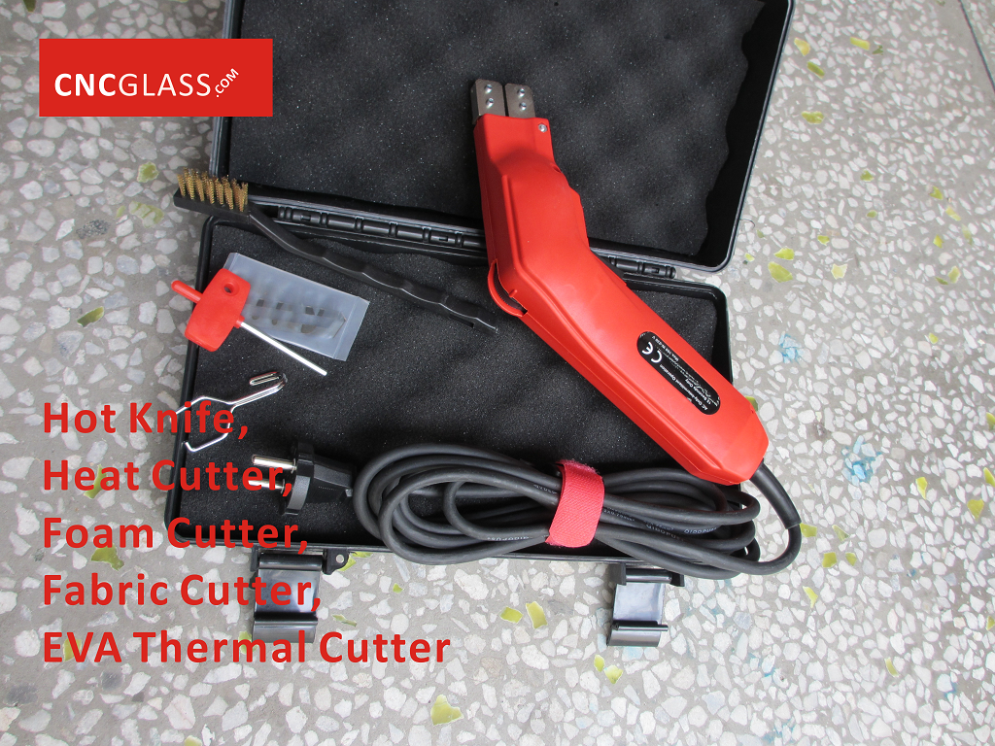

Technical Data:
Supply voltage: 230V/50Hz(110V/60Hz)
Power input: 120W
Intermittent operation: 1/4 min
Weight: 1.0Kg
Power cord length: 3.0m

Basic Kit:
Handle, 100mm blade, Tool box,cleaning brush and spanner.

Hot Knife polystyrene foam cutter is a great all around hot knife foam cutter. Excellent for contractors, hobbyist, shipping departments and anywhere else one needs to cut expanded or extruded polystyrene foam. Our customers prefer cutting foam with the Hot Knife because of how clean it cuts and leaves no dust compared to cutting with a saw.

Electric heating cutter available in several blades to remove the remains of EVA film of laminated glass

Introduction:
The Hot Knife(Heat Cutter, Foam Cutter, Fabric Cutter, EVA Thermal Cutter) is a professional-grade hot cutting tool for EVA Film&Fabrics. The Hot Knife(Heat Cutter, Foam Cutter, Fabric Cutter, EVA Thermal Cutter) heats up in seconds and gives the operator temperature control. Never before has working with EVA Film&Fabrics been this easy, inexpensive and free of mess.
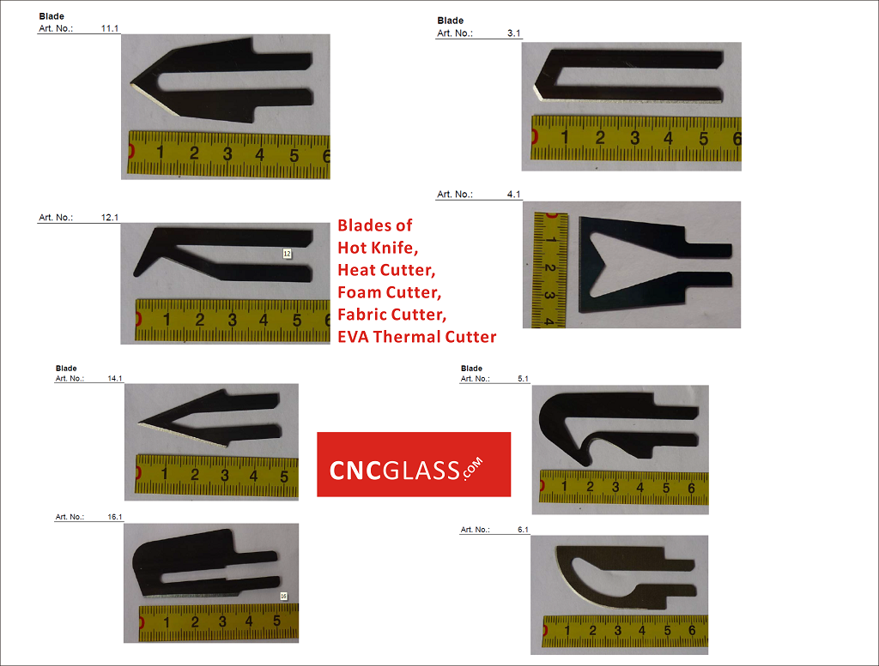
Recommended Use:
Terylene EVA Film&Fabrics, EVA Film of laminated glass, PVB Film of laminated glass, SGP Film of laminated glass, Fiberglass Fabrics and Polyester Fabrics can be easily cut with Hot Knife(Heat Cutter, Foam Cutter, Fabric Cutter, EVA Thermal Cutter) .

Blade Installation:
NOTE: Always unplug cord of the Hot Knife(Heat Cutter, Foam Cutter, Fabric Cutter, EVA Thermal Cutter) before installing or removing the blades. Allow sufficient cooling time for blades, blade holders and metal thumb wheels before handing.

Caution 1: The Hot Knife(Heat Cutter, Foam Cutter, Fabric Cutter, EVA Thermal Cutter) blade have a sharpened razor edge, for the cleanest cut always cut in the direction on the sharpened edge.

Blades:
1-Loosen the screws on the blade holders with the wrench.
2-Slide the blade under the square pressure plate until snug
3-Securely tighten screws to assure the proper electrical connection. Do not over-tighten.
4-Once the blade is firmly in place, plug in the Hot Knife(Heat Cutter, Foam Cutter, Fabric Cutter, EVA Thermal Cutter) Unit into a standard power supply.
5-The temperature control knob has 16 click setting that correspond to the graduated ridges on the surface. The smaller the ridge the lower the power setting.

Caution 2: Excessive power output and heat generation may cause the blade holders to overheat resulting in damage to the unit. Use only the power output for proper cutting. The blade does not need to be red hot to move through foamed plastics.

Operation:
Put your temperature control knob at midrange setting, place the blade against the edge of the foam and depress trigger. Optimum cutting should be virtually smoke free.

NOTE: For the best results, practice on scrap pieces of EVA Film&Fabrics .

When cutting foam it is best to keep the temperature and speed consistent. If smoke develops during the cut, you are cutting too slow or the blade is to hot which could result in an over-sized, uneven cut. This can be remedied by lowering the temperature and intermittently releasing the trigger during your cut. As the cutting resistance increases, depress the trigger again. The Hot Knife(Heat Cutter, Foam Cutter, Fabric Cutter, EVA Thermal Cutter) will reach the set temperature within seconds. You can accomplish your cut with minimal smoke using this process. Cutting in this manner will also prolong the life of the knife.

Releasing the trigger approximately one or tow inches prior to the completion of the cut will help keep the blade clean and free from buildup

Caution 3:
Always operate the Hot Knife(Heat Cutter, Foam Cutter, Fabric Cutter, EVA Thermal Cutter) in well ventilated space
Never burn off excess residue on the hot knife blade. The blades will overheat, warping the blade and potentially overheating the Hot Knife(Heat Cutter, Foam Cutter, Fabric Cutter, EVA Thermal Cutter) .
Only operate Hot Knife(Heat Cutter, Foam Cutter, Fabric Cutter, EVA Thermal Cutter) when it is in contact with the insulation board.
Keep hot blades away from skin, clothing and other flammable materials.
Allow blades to cool before handling. A hot blade may cause injury or burns to exposed surfaces.

Maintenance:
Constant use of the Hot Knife(Heat Cutter, Foam Cutter, Fabric Cutter, EVA Thermal Cutter) may result in some material build up on blades and the brass holders. This excess material interferes with the proper electrical and impairs the performance of the blades. The brass blade holders and blades can be thoroughly cleaned with a wire brush.

Customer Review:
Loved it very much! I used the hot knife for cutting 4'x8' sheets of styrofoam insulation (1" thick) to make mural backdrops. Great product! I had so much fun cutting a skyline to make a backdrop. Since then, I've had several people ask to borrow it. If you've ever tried to cut styrofoam with a saw or regular knife you know what a mess it makes, but this seals the edges as it cuts and keeps the "little micro-beads" of styrofoam under control.


All rights reserved by CNC GLASS INTERLAYER TECH:
Product 1]CNC EVA INERLAYER FOR ARCHITECTURAL LAMINATED GLASS
Product 2]CNC PDLC SMART FILM FOR PRIVACY SWITCHABLE GLASS
Product 3]CNC PVB INTERLAYER FOR AUTOMOTIVE WINDSHIELD GLASS


